Eddie Ramírez  Graphic Designer - Social & Brand | Vancouver BC. V5R3M1  +1 778 201 5243  eddie.ramgon@gmail.com  www.alofish.net
EXPERIENCE  Cadspiderman — Vancouver, Canada April 2022-Present  Visual identity, social media & trade marketing  www.cadspiderman.com  Vallarta Adventures — Senior Graphic Design 2014-2020  MEXICO. Puerto Vallarta. Los Cabos. Cancun  - In charge of quotes, inventories, and facilities  - Transportation labeling (ground & maritime)  - Institutional stationery, uniforms, and signs  - Advertising campaigns & publications  Señor Frogs — Graphic Design & E-commerce 2010-2013  MEXICO. Puerto Vallarta & Cancun  E-marketing, character development, advertising graphic design & photography  EDUCATION  Canada International Royal Arts Vancouver — Diploma  2020 - 2022  Media design & Web development.  Universidad del Valle de Atemajac, Mexico — College  MEXICO: 2003-2007  Graphic Design & Communications  PROJECTS  #iluvafro — Motions graphics & artificial intelligence  Illustrations · Stickers · Reels · Commercials · Social Media | SKILLS  - Visual identity  - Marketing & advertising  - Publication graphic design  - UI / UX Design  - Illustration  - Motion graphic design  ABOUT ME  As a designer I love to connect passion with creativity, it is the most inspiring energy that you could create.​  Hobbies: dancing, swimming & cycling.  SOFTWARE  Illustrator · Photoshop  APPS  Figma · Wix · WordPress  Dream AI & Kaiber

COVER LETTER

I'm Eddie, and I'm passionate about making creativity and passion work together.
it is the most inspiring energy you could create.​
This energy drives me to get to know my clients' values, target audience, and business goals so that my designs accurately reflect their vision, priorities, and beliefs.
Taking great pride in my work, I look forward to working with you.

Skills: Artificial Intelligence, Visual Identity, Trade Marketing, Web Development,
Illustrations & Motion Graphic Design

EXPERIENCE / PUERTO VALLARTA / MEXICO
Adventures Group / Publicity & Trade Marketing / 6 years experience
Being part of this amazing crew and working for a truly world-class company, I found immense joy in the process of selecting photos for the weekly uploads. It was an incredibly rewarding experience, and I felt a strong sense of pride.
Leading various principal tasks, including handling print media and designing institutional stationery, uniforms, and signs, gave me valuable experience in trade marketing and graphic design.
I developed a robust skill set in branding, communication, and effective setting and managing design timelines as I took on the biggest dare of managing three locations (Los Cabos, Cancun, and Puerto Vallarta).
The warehouse for advertising was under my management.
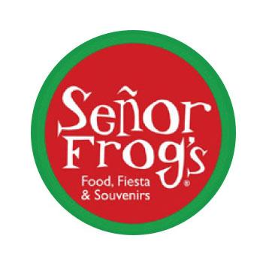
Señor Frogs / Graphic Design & E-Commerce / 3 years experienceT
his restaurant is amazingly fun, designing over 25 characters, coordinating events, and taking charge of photography were among my favorite tasks. Moreover, I gained valuable knowledge in sales, promotions, public relations, social media marketing, and sponsor negotiations. Notably, one of my biggest achievements was successfully designing characters, and witnessing the fulfillment of seeing my creations on T-shirts and other merchandise brought me immense satisfaction.

